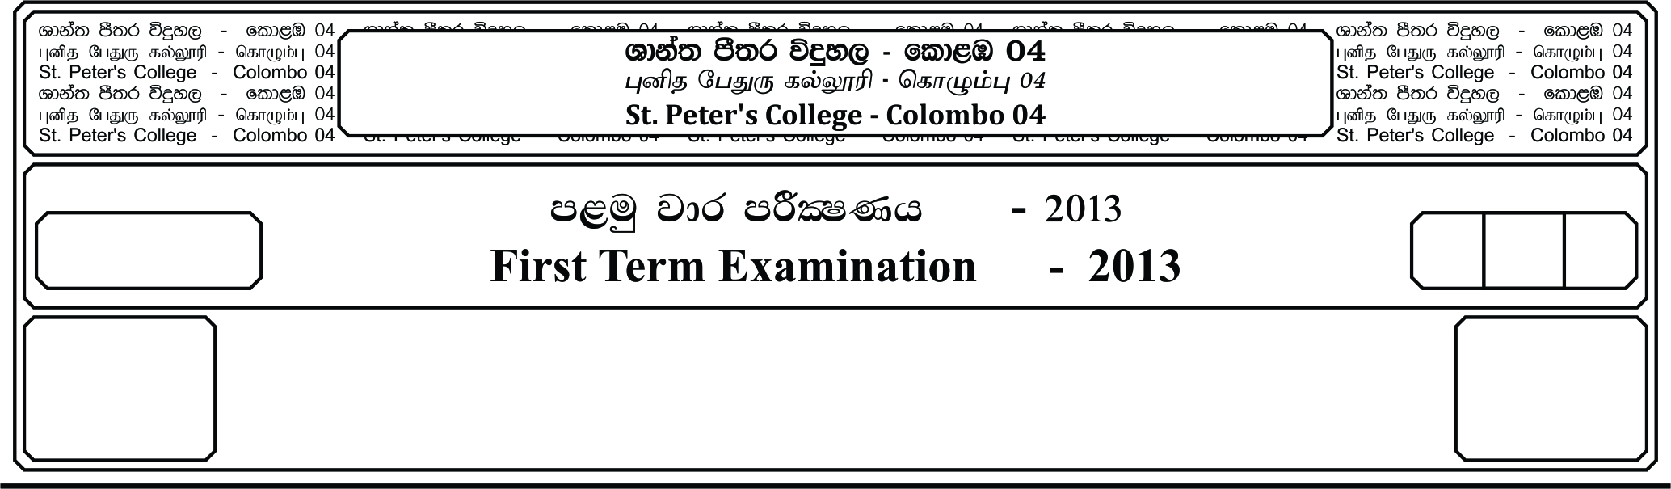

E

I

**m<uq jdr mßlaIKh - 2019**

**First Term Examination- - 2019**

12 fY%aKsh

GRADE 12

.sKqïlrKh

**Accounting**

meh 02

02 Hours

***Part I***

**Answer to all questions**

**1.** Steve started business on 1st of April 2019 with Rs.500000 capital and bank loan Rs.200 0000. He provided service for Rs.350000 and incurred expenses were Rs.280000, closing equity was Rs.570000

and asset were Rs. 670000.what is the liability value at the end of the year.

1)100000 2)200000 3)130000 4)180000 5)70000

1. The primary objective of Financial Accounting is,
   1. To provide information about an entity to take decisions by managers.
   2. To provide information about an entity to its interested parties for decision making.
   3. To provide information to the government for calculation of tax on income.
   4. To provide information to the auditors to express an opinion about the financial statement.
   5. To provide information about the compliance with accounting standards to supervise.
2. Management accounting
3. Uses historic and budgeted information both
4. assists for planning and controlling C) provides information only to management.

**Out of the above statements**

1) An only correct 2) B only correct 3) A and B only correct 4) A and C only correct

5) A B C all are correct

1. Accounting was introduced in,
   1. 1431 2) 1497 3) 1479 4) 1494 5) 1449

1. Returnedinwardaccount **is** a/an

1). asset acc 2). Expense acc. 3). Income acc. 4) Equity acc. 5). liabilities acc.

1. Dylan started a business investing 500. During the month he bought goods for 500 and stock was sold with a profit. Total expenditure for the month was 190. If equity at the end of the month was 560 profit margin on cost as a percentage is,
   1. 20% 2) 30% 3) 40% 4) 45% 5) 50%
2. Select the incorrect equation
   1. P = NA2 - NA1 - AC + D 2. NA2 = P + NA1 + AC - D 3. NA1 = P - NA2 + AC - D

4. AC = P - NA2 + NA1 – D 5. D = P + NA + NA1 + AC

1. Vishwa traders trade details for ate month of April 2019 were as follows.

Cash purchases 500000

Credit purchases 600000

Returned outwards 100000

Sold 1000 000worth stock for 1200 000

Closing stock at the end of the month is,

* 1. 100000 2). Nil 3) 200000 4) 400000 5). 120000

1. Niluk plc credit Information is as follows

Credit sales 600 000 credit purchases 750 000

Cash paid to creditors 300 000 cash received from debtors 200 000

Returned inwards 100 000 returned outwards 150 000

The difference between debtors and creditors balance is

1). 300000 2). 450000 3). Nil 4). 150000 5). None of the above

1. Select the incorrect statement regarding with the profit and loss account.

1). It is prepared on cash basis

2). It is an understandable presentation of profit and loss account

3). It shows the operational performance of the year.

4). It's apart of financial statements.

5). its results will be transferred to the equity account.

1. There is a difference of Rs.2000 in physical value of inventory and inventory records. The business management identified the shortage as a default of store keeper and decided to charge 50% of loss from stock manager. Show the above impact in the basic accounting equation
   1. = E + L

|  |
| --- |
| = + |

1. Sold a stock for Rs .46, 000 including 15% of VAT which was purchased for Rs. 25,000
   1. = E + L

|  |
| --- |
| = + |

1. Sold a stock purchased for Rs.500, 000 with a 20% of profit and 15% VAT
   1. = E + L

|  |
| --- |
| = + |

Write journal entry to record following transactions for questions 14 and 15

1. Stock worth 800 was destroyed and Insurance Company agreed to pay 80% of damage

……………………………………………………………

……………………………………………………………

…………………………………………………………...

..………………………………………………………….

1. Donated stock of 75

…………………………………………………………………………………………….

…………………………………………………………………………………………..

Fill in the blanks with suitable terms for questions 16 to 20

1. Accounting information is divided into two as ………………………………………………………………………….

And ……………………………………………………………………..

1. Financial statements are divided into two based on user group as

……………………………………………………………….. & ………………………………………………………………………………………

1. ………………………………………………………………. Is prepared to evaluate the operational performance of the business
2. All transactions and events will be recorded in books according to the accounting view of

……………………………………………………………………………

1. Introducing a new software belongs to the ……………………………………………………………. Environment.

***PART II***

01. Sayuri Traders transactions took place during the month of April 2019 were as follows(‘000’)

|  |  |
| --- | --- |
| 1/4 | Investing capital 800 in cash and 120 worth building |
| 5/4 | Obtained a bank loan of 500 |
| 10/4 | Bought goods on credit 600 |
| 12/4 | Sold goods on credit 900 |
| 18/4 | Debtor returned 200 ( included profit margin in returned stock was 50) |
| 20/4 | Received an advance for 400 to supply goods in next month |
| 25/4 | Paid building rent 75 up to June 31st |
| 26/4 | Paid bank loan 25 including interest 5 |
| 28/4 | Cash paid to creditors 90 after receiving 10% discount |
| 30/4 | Sayuri has taken 20 worth stock for her personal use. |

Additional:

• Building life time is limited to 10 years

1. Record the above transactions to the given accounting equation

**PPE + Stock + Debtors + Prepayments + Cash = Equity + Bank Loan + Creditor + Other payables**

2. Prepare Income Statement for the month of April 2019

**02.** Following transaction took place in Seshan Traders who commenced a business on 01/4/2018.

.Investing capital in cash 100 by a motor vehicle 600 and building 300

.Cash sales 700

.Opened a current a/c in a commercial bank depositing 400

.Bought goods on credit 500

.Paid cash to above creditor by cheque receiving 10% discount

.Bought goods for cash 600

.Received cash from a customer to supply goods in May 2019 for 500 .Sold goods on credit 400.

.Debtor returned goods 80

.Received cash from the above debtor by a cheque after allowing 10% discount .Credit sales 800

.Stock worth 100 was destroyed due to fire and Insurance Company agreed to pay 80% of damage

.The owner has taken stock worth 40 for his personal use

.Paid salaries by cheque 90

.Donated stock to charity 40

.Sold goods on credit 200

.Debtor returned goods 100

You are required to record these transactions,

1. In relevant ledger a/c
2. Preparing trial balance
3. Preparing Profit and Loss Statement and Statement of Financial Position as at 31/3/19